A TECHNICAL REPORT ON STUENTS INDUSTRIAL WORK EXPERIENCE SCHEME (SIWES)

TITLE PAGE
AT

DEEN TECHNICAL WORKSHOP LTD,
MUBI NORTH, ADAMAWA STATE

FROM: 06TH OCTOBER, 2023
TO: 29TH JANUARY, 2024

BY

UNWANA JOHN UDOUKPONG
ET/ME/ND/22/049

DEPARTMENT OF MECHANICAL ENGINEERING TECHNOLOGY FEDERAL POLYTECHNIC, MUBI.

JULY, 2024.

A TECHNICAL REPORT ON STUENTS INDUSTRIAL WORK EXPERIENCE SCHEME (SIWES)

TITLE PAGE
AT

DEEN TECHNICAL WORKSHOP LTD,
MUBI NORTH, ADAMAWA STATE

FROM: 06TH OCTOBER, 2023
TO: 29TH JANUARY, 2024

BY

UNWANA JOHN UDOUKPONG
ET/ME/ND/22/049

DEPARTMENT OF MECHANICAL ENGINEERING TECHNOLOGY FEDERAL POLYTECHNIC, MUBI.
THIS TECHNICAL REPORT IS SUBMITTED TO THE DEPARTMENT OF MECHANICAL ENGINEERING TECHNOLOGY, FEDERAL POLYTECHNIC MUBI
IN PARTIAL FULFILMENT OF THE REQUIREMENTS FOR THE AWARD OF NATIONAL DIPLOMA (ND) IN IN MECHANICAL ENGINEERING TECHNOLOGY, FEDERAL POLYTECHNIC MUBI

JULY, 2024.

APPROVAL PAGE
This SIWES report written by Unwana John Udoukpong ET/ME/ND/22/049 was certified and approved by the following

SIWES Supervisor _____________ _____________
Mr. Princewill Edet Sign Date

Dr. Mohammed Bashir A. _____________ _____________
SIWES Coordinator Sign Date

Mr. Cosmas Tizhe _____________ _____________
Head of Department Sign Date

DEDICATION
This work is dedicated to my beloved parents for leading me into intellectual pursuit by giving me the financial support, in addition to the enormous contribution (financially and morally) made by my brothers and family members.

ACKNOWLEDMENTS
All glory be to God almighty the creator of heaven and earth for his sufficient grace throughout the period of my SIWES program and I thank God for giving this great opportunity.
I also thank my family, friends and relative for supporting me morally and financially throughout my education and successful completion of my student industrial work experience scheme (SIWES) program.
I would also like to express my infinite thanks to the entire management and staff of Dean Technical Workshop for honoring me and accepting my application and helpful relation accorded to me during the period of my attachment.
I also thank my industrial supervisor for his dedication, concern and contribution during the period of my SIWES program. Finally, I will like to show my appreciation to my Head of Department, my SIWES Supervisor and all staff of Mechanical Engineering Federal Polytechnic Mubi, Adamawa state of Nigerian

SUMMARY
This technical report comprises of four (4) chapters. Chapter one comprises of Introduction to SIWES, History of SIWES, Aim and Objectives of SIWES, chapter two comprises of working experience from changing of Piston, removing of top cyclinder, the complaints, tools/materials used, the steps and precautionary measures applied, chapter three comprises of experiences gotten from Changing of bearing, the complaints, tools/materials used, the steps and precautionary measures applied. Chapter four comprises of the Conclusion and the Recommendation on the SIWES.

TABLE OF CONTENTS

TITLE PAGE i
TITLE PAGE ii
APPROVAL PAGE iii
DEDICATION iv
ACKNOWLEDMENTS v
SUMMARY vi
TABLE OF CONTENTS vii
CHAPTER ONE 1
INTRODUCTION 1
1.1 Brief history of SIWES 1
1.2 Aims and objectives of SIWES 2
1.3 Brief History of Organization 3
1.4 Organizational chart 3
CHAPTER TWO 4
2.1 Changing of Piston and Rings 4
2.1.1 Complaint 4
2.1.2 Observation 4
2.1.3 Tools used 4
2.1.4 Procedure 4
2.1.5 Precaution 5
2.2 Rethreading of Top Cylinder 6
2.2.1 Complaint/Problem 6
2.3 Polishing Crankshaft 9

CHAPTER THREE 12
3.1 Changing of Bearing 12
3.1.1 Complaint/Problem 12
3.1.2 Observation 12
3.1.3 Tools 12
3.1.4 Procedure 12
3.1.5 Precaution 13
3.2 Reboring of Engine Block 14
CHAPTER FOUR 17
CONCLUSION AND RECOMMENDATIONS 17
4.1 Conclusion 17
4.2 Recommendation 17
REFERENCES 19

CHAPTER ONE

INTRODUCTION

1.1 Brief history of SIWES
SIWES was founded in 1973 by ITF (Industrial Training Funds) to address the problem of tertiary institution graduates' lack of appropriate skills for employment in Nigerian industries. The Students' Industrial Work Experience Scheme (SIWES) was founded to be a skill training programme to help expose and prepare students of universities, Polytechnics and colleges of education for the industrial work situation to be met after graduation.
This system facilitates the transfer from the classroom to the workplace and aids in the application of knowledge. The program allows students to become acquainted with and exposed to the experience required in handling and operating equipment and machinery that are typically not available at their schools.
Prior to the establishment of this scheme, there was a rising concern and trend among industrialists that graduates from higher education institutions lacked appropriate practical experience for employment. Students who entered Nigerian universities to study science and technology were not previously trained in the practical aspects of their chosen fields. As a result of their lack of work experience, they had difficulty finding work.
As a result, employers believed that theoretical education in higher education was unresponsive to the needs of labor employers. Thousands of Nigerians faced this difficulty till 1973. The fund's main motivation for establishing and designing the scheme in 1973/74 was launched against this context.
The ITF (Industrial Training Fund) organization decided to aid all interested Nigerian students and created the SIWES program. The federal government officially approved and presented it in 1974. During its early years, the scheme was entirely supported by the ITF, but as the financial commitment became too much for the fund, it withdrew in 1978. The National Universities Commission (NUC) and the National Board for Technical Education (NBTE) were given control of the scheme by the federal government in 1979. The federal government handed over supervision and implementation of the scheme to ITF in November 1984. It was taken over by the Industrial Training Fund (ITF) in July 1985, with the federal government bearing entire responsibility for funding.

1.2 Aims and objectives of SIWES
The Industrial Training Fund’s Policy Document No. 1 of 1973 which established SIWES outlined the objectives of the scheme as:
- Provide an avenue for students in Institutions of higher learning to acquire industrial skills and experience in their respective courses of study.
- Prepare students for the Industrial Work situation they are likely to experience after graduation.
- Expose students to work methods and techniques of handling equipment and machinery that may not be available in their Institutions.
- Make the transition from school to the world of work easier; and enhance students’ networks for later job placements.
- Provide students with an opportunity to apply their knowledge to real work situations, thereby bridging the gap between theory and practice; and vi. Enlist and strengthen Employers’ involvement in the entire educational process; thereby preparing the students for employment in Industry and Commerce.

1.3 Brief History of Organization
Deen Technical Workshop ltd was established in 1985 in Maiduguri and it encountered some challenges before it moved to Mubi, Adamawa State in 1991 and by the help of God Deen Technical Workshop Limited has been able to establish a branch in Jimeta, Yola Adamawa State, Nigeria.

1.4 Organizational chart
WORKSHOP
MANAGER
WORKSHOP
ASST. MASTER

WORKSHOP
APPRENTICE

Figure 1.1: Organizational Chart

CHAPTER TWO
WORK EXPERIENCE

2.1 Changing of Piston and Rings

2.1.1 Complaint
A mechanic came with a car complaining of an overheating and stopping of the car when not required to.

2.1.2 Observation
The work carried out on the engine was changing the piston rings.
The wear of piston rings was identified by the white smoke coming out of the exhaust pipe and by shaking the piston inside the cylinder block to see whether the piston is shaking or not.

2.1.3 Tools used
Socket set, a torque wrench, and a piston ring compressor, feeler gauge, piston ring expander and a micrometer or caliper.

2.1.4 Procedure
- To change the piston rings, the battery was first disconnected followed by carburetor linkages, cylinder head cover, after loosening out the securing bolts the cylinder head was removed exposing the piston in the cylinder.
- After the sump securing nuts and bolts were loosed, a clearance was created for easy access to the connecting rod nut which was loosed, allowing withdrawal of the piston alongside with the connecting rod.
- Coupling of the Dismantled Engine Top Cylinder.
- The various parts of the engine were rinsed with petrol solvent. To couple the loosed parts the new piston rings were replaced into the piston sleeves and was smeared with engine oil.
- Piston crown was used for clamping the piston together with the piston number 1 and 4 as it was turned to the bottom dead center and then, the bearings caps was tightened and turn the piston number 2 and 3 to the bottom dead center and their bearings were tightened properly.
- The oil pump was replaced back to its normal position, the oil sump covering the bottom were tightened properly.
- The cylinder head was replaced back and fastened properly.

2.1.5 Precaution
- Ensured the work area and engine components were clean to prevent contamination.
- Followed the manufacturer's torque specifications and assembly instructions precisely.
- Inspected all parts for wear or damage and replaced any faulty components before reassembly.
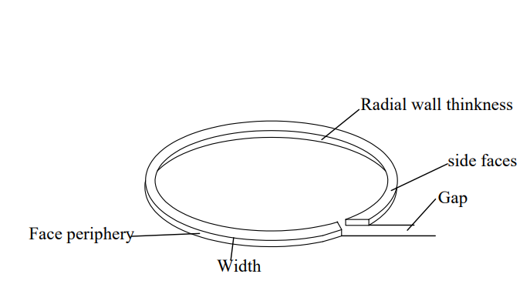
Figure 2.1: sketch of Rings.
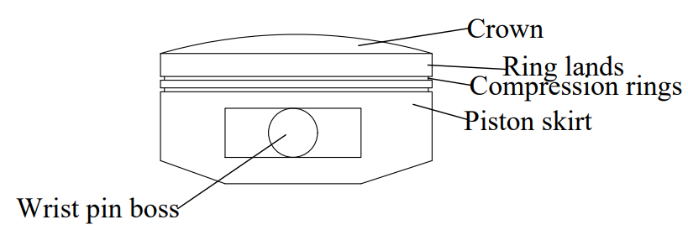
Figure 2.2: Sketch of the engine piston.

2.2 Rethreading of Top Cylinder

2.2.1 Complaint/Problem
The engine was experiencing a loss of compression and abnormal noise, indicating potential issues with the threads in the top cylinder.

2.2.2 Observation
Upon inspection, it was noted that the threads for the cylinder head bolts were stripped or damaged, preventing proper sealing and resulting in compression loss.

2.2.3 Tools
Thread repair kit, Socket set, Torque wrench, Screwdrivers, Wrenches, Pliers, Engine hoist or support bar, Gasket scraper, Feeler gauge, Soft-faced hammer, Circlip pliers.

2.2.4 Procedure
- Safety First: Disconnect the battery to ensure safety during the procedure.
- Fluid Drainage: Drain the engine oil and coolant to prevent spillage during work.
- Accessing Components: Remove the air filter assembly, intake manifold, and exhaust manifold to access the cylinder head.
- Detaching Ancillaries: Disconnect any ancillary components, such as sensors, hoses, and electrical connections attached to the cylinder head.
- Removing the Cylinder Head: Unbolt the cylinder head bolts in the correct sequence to avoid warping or damaging the head. Carefully lift the cylinder head off the engine block, ensuring not to damage the gasket or surrounding components.
- Inspection of Threads: Examine the bolt holes in the cylinder head for damage.
- Rethreading Process: Use the thread repair kit to rethread the damaged bolt holes according to the manufacturer's instructions. This may involve drilling out the damaged threads, tapping new threads, and inserting helicoils or equivalent thread inserts.
- Reassembling Components: Once the threads have been repaired, clean the cylinder head and surrounding components thoroughly.
- Reinstalling the Cylinder Head: Carefully position the cylinder head back onto the engine block and install new gaskets as required.
- Torque Specifications: Use a torque wrench to secure the cylinder head bolts according to the manufacturer's specifications.
- Final Checks: Reinstall the rocker arms and pushrods, and replace the valve cover. Ensure all components are correctly connected and secured.

2.2.5 Precautions
- Maintain Cleanliness: Ensure the work area and engine components are clean to prevent contamination during the rethreading process.
- Use Proper Tools: Always use a torque wrench to adhere to the manufacturer's specifications when reassembling bolts.
- Inspect All Parts: Carefully inspect all parts for wear or damage, replacing any faulty components before reassembly to avoid further engine issues.
- iv. Test Compression: After reassembly, perform a compression test to verify that the rethreading process has resolved the initial issues.
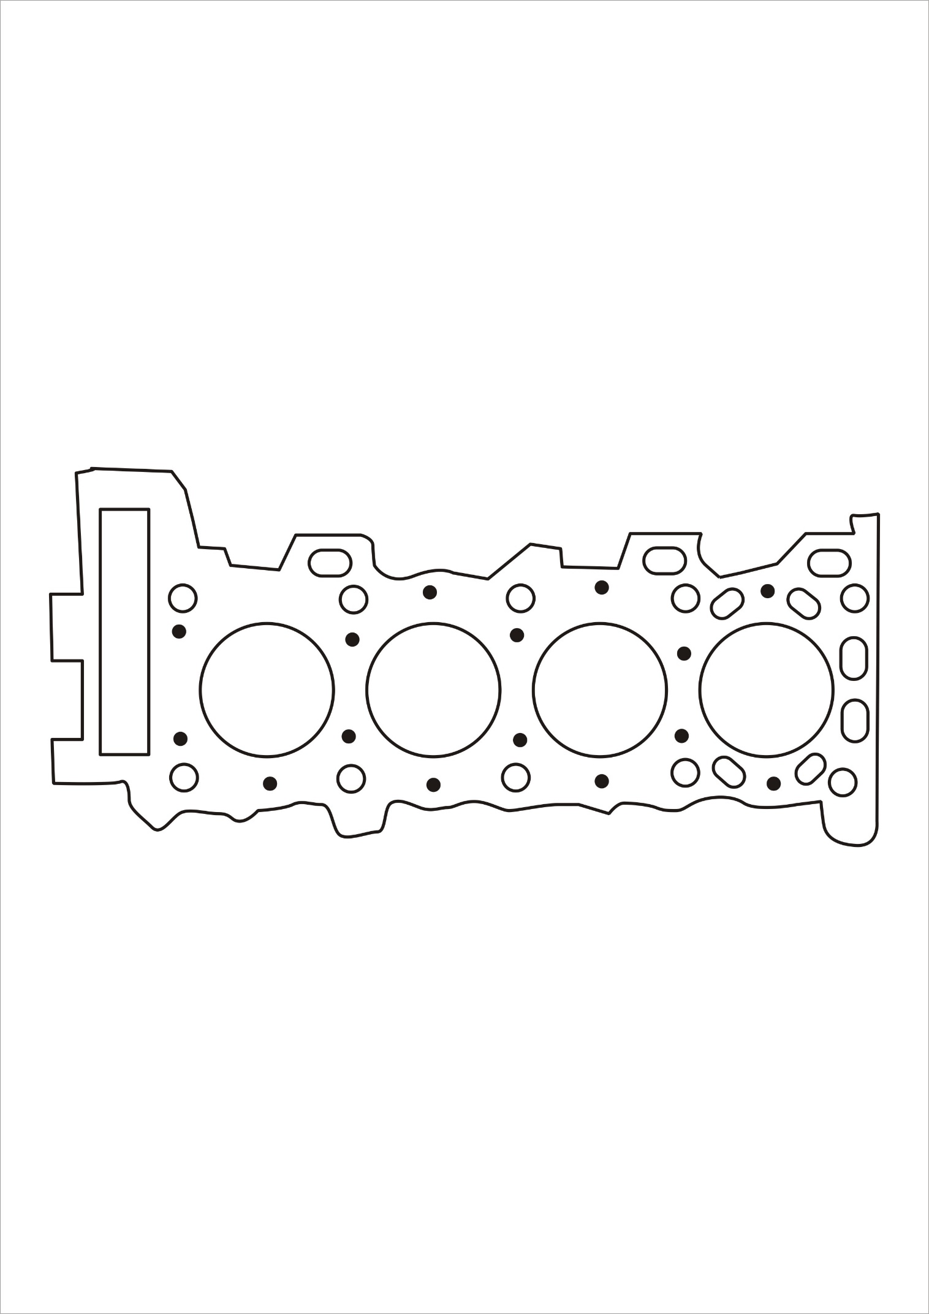
Figure 2.3: Top Cylinder

2.3 Polishing Crankshaft

2.3.1 Complaint/Problem
The engine was exhibiting vibrations and irregular performance, indicating potential issues with the crankshaft's surface finish, which could lead to improper sealing and increased wear.

2.3.2 Observation
Upon inspection, it was noted that the crankshaft had visible scratches, scoring, and an uneven surface, which could negatively impact engine performance and longevity.

2.3.3 Tools
Lathe machine, Crankshaft polishing kit, Socket set, Torque wrench, Screwdrivers, Wrenches, Pliers, Engine hoist or support bar, Gasket scraper, Soft cloths or polishing rags, Micrometer or caliper, Lubricating oil.

2.2.4 Procedure
- Safety First: Disconnect the battery to ensure safety during the procedure.
- Fluid Drainage: Drain the engine oil and coolant to prevent spillage during work.
- Accessing Components: Remove any components obstructing access to the crankshaft, such as the oil pan, timing cover, and accessory drive components.
- Detach the Crankshaft: Unbolt and carefully remove the crankshaft from the engine block, following the proper sequence to avoid damage.
- Initial Inspection: Examine the crankshaft for any signs of significant wear, cracks, or damage before proceeding with polishing.
- Preparing for Polishing: Clean the crankshaft thoroughly to remove oil, dirt, and debris that may interfere with the polishing process.
- Polishing Process: Using the crankshaft polishing kit, apply the appropriate polishing compound to the polishing pads. Work the pads along the surface of the crankshaft in a consistent manner, maintaining even pressure to achieve a smooth finish.
- Measure Surface Finish: Use a micrometer or caliper to measure the crankshaft’s surface finish and ensure it meets the manufacturer's specifications.
- Final Cleaning: After polishing, clean the crankshaft again to remove any residual polishing compound and debris.
- Reinstalling the Crankshaft: Carefully position the polished crankshaft back into the engine block, ensuring proper alignment and fit.
- Torque Specifications: Use a torque wrench to secure the crankshaft bolts according to the manufacturer's specifications.
- Reassemble Components: Reinstall any components that were removed to access the crankshaft, ensuring all connections are secure and properly fitted.

2.2.5 Precautions
- Maintain Cleanliness: Ensure the work area and crankshaft are clean to prevent contamination during the polishing process.
- Use Proper Tools: Always use the recommended polishing tools and compounds to avoid damaging the crankshaft surface.
- Inspect All Parts: Carefully inspect all parts for wear or damage, replacing any faulty components before reassembly to avoid further engine issues.
- Test Engine Performance: After reassembly, run the engine to verify that the polishing process has resolved any performance issues and that it operates smoothly.

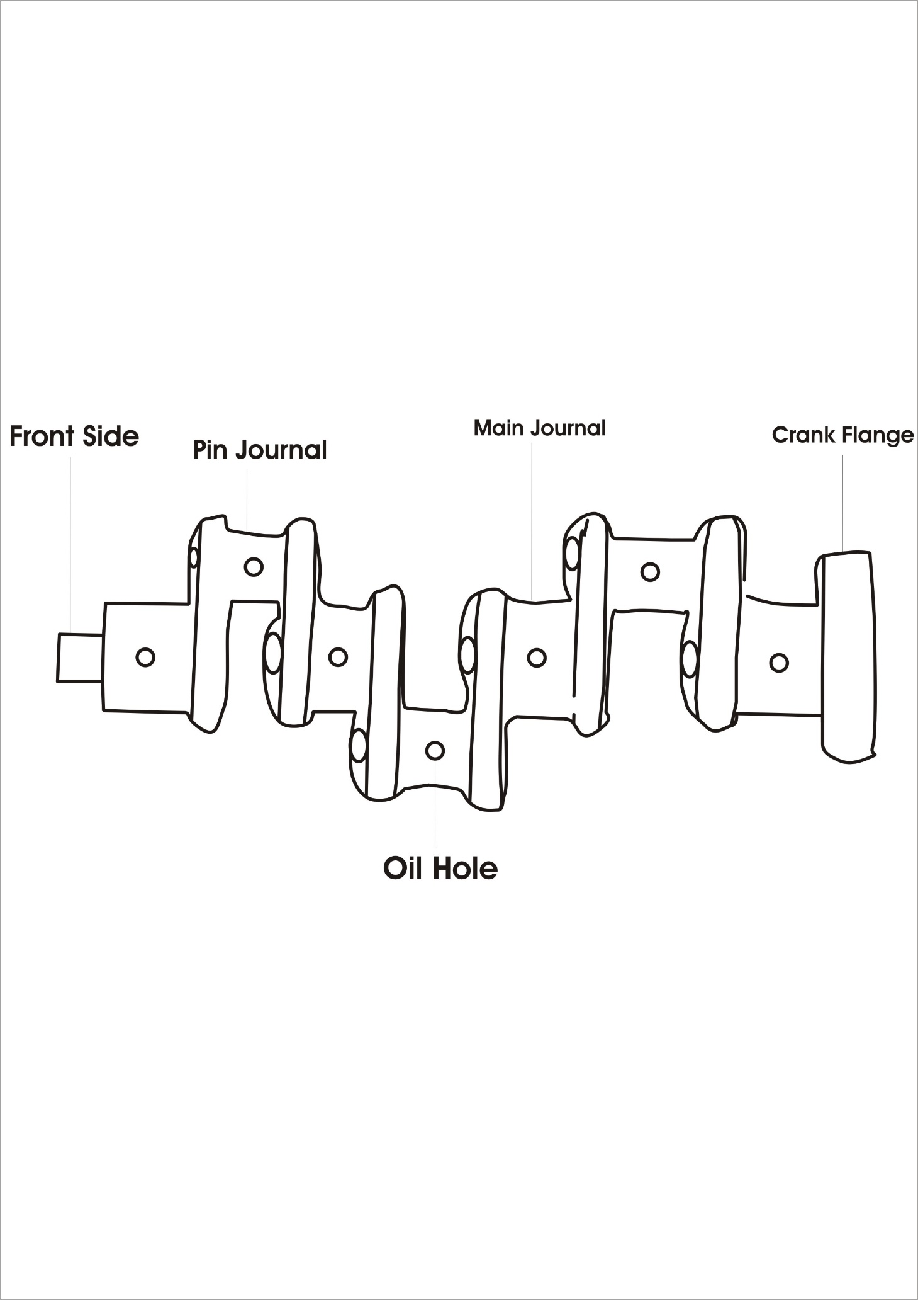
Figure 2.4: Crankshaft

CHAPTER THREE
WORK EXPERIENCE

3.1 Changing of Bearing

3.1.1 Complaint/Problem
A mechanic came and requested for a change of bearings.

3.1.2 Observation
During inspection, it was observed that the bearings were worn out, showing signs of scoring and excessive play.

3.1.3 Tools
The tools used for changing bearings included a socket set, wrenches, torque wrench, oil filter wrench, soft-faced hammer, micrometer or caliper, bearing puller, assembly lube, and a clean cloth.

3.1.4 Procedure
  - Disconnected the battery to ensure safety.
  - Drained the engine oil to prevent spills and contamination.
  - Removed the oil pan to access the crankshaft and bearings.
  - Detached any ancillary components, such as sensors, hoses, and electrical connections that obstructed access to the bearings.
  - Unbolted the main bearing caps and rod caps to remove the crankshaft and connecting rods.
  - Carefully removed the old bearings from their seats, noting their orientation and placement.
  - Cleaned the bearing seats and surrounding areas thoroughly.
  - Installed the new bearings, ensuring they were correctly aligned and seated.
  - Applied assembly lube to the new bearings to ensure proper lubrication during initial startup.
  - Reinstalled the crankshaft and connecting rods, securing them with the main bearing caps and rod caps.
  - Tightened all bolts to the manufacturer's specified torque settings using a torque wrench.
  - Reinstalled the oil pan, refilled the engine with fresh oil, and reconnected any removed components.

3.1.5 Precaution
  - Ensured the work area and engine components were clean to prevent contamination and potential damage.
  - Used a torque wrench to adhere to the manufacturer's specifications when removing and reassembling bolts, ensuring proper bearing fit and function.
  - Carefully inspected all parts for wear or damage and replaced any faulty components before reassembly to ensure the engine's longevity and performance.

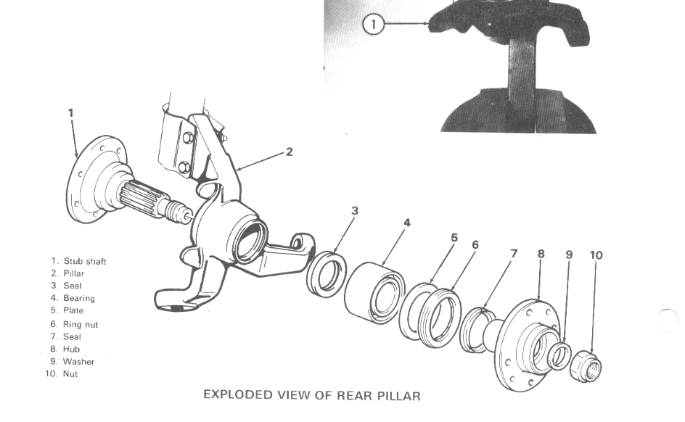
Figure 3.1: Bearing

3.2 Reboring of Engine Block

3.2.1 Complaint/Problem
A mechanic reported that the engine block required reboring due to cylinder wear, which was causing poor engine performance and increased oil consumption.

3.2.2 Observation
During the inspection, it was observed that the cylinder walls were significantly worn, with visible scoring and out-of-roundness, resulting in loss of compression and inefficient operation.

3.2.3 Tools
The tools used for the reboring process included a boring machine, micrometer or dial bore gauge (for measuring cylinder dimensions), piston ring compressor, torque wrench, socket set, engine hoist (if necessary), assembly lube, soft-faced hammer, and a clean cloth.

3.2.4 Procedure
- Engine Disassembly: The engine block was carefully disassembled, removing the cylinder head, pistons, crankshaft, and other components to access the cylinder bores.
- Cylinder Measurement: The worn cylinder bores were measured using a micrometer or dial bore gauge to determine the extent of wear and the amount of material that needed to be removed during reboring.
- Setup of Boring Machine: The engine block was mounted securely onto the boring machine, aligning it properly to ensure precise cuts.
- Boring Process: The boring machine was used to enlarge the worn-out cylinders to the next oversize, ensuring smooth and even cuts to restore the cylinders to their original roundness.
- Honing: After reboring, the cylinder walls were honed to achieve the required surface finish, allowing for proper piston ring sealing.
- Inspection: The newly bored cylinders were inspected with a micrometer or dial bore gauge to confirm they met the required dimensions and tolerances.
- Cleaning: The engine block was thoroughly cleaned to remove any metal shavings and debris from the reboring process, ensuring no contaminants would affect the engine's operation.
- Piston and Ring Installation: New oversized pistons and rings were installed, ensuring proper fit in the newly bored cylinders. Assembly lube was applied to ensure smooth operation during startup.
- Reassembly: The engine block was reassembled, with the crankshaft, pistons, and other components carefully reinstalled and secured using a torque wrench to tighten bolts to the manufacturer’s specifications.
- Testing: Once reassembled, the engine was tested to ensure the reboring had resolved the issues and that the engine was functioning efficiently.

3.2.5 Precaution
- Cleanliness: The work area and engine components were kept clean to prevent contamination and ensure smooth operation of the reconditioned engine.
- Precision Measurement: All cylinder dimensions were measured carefully using a micrometer or dial bore gauge to ensure accuracy during reboring and proper fit of the new pistons.
- Torque Specifications: All bolts were tightened to the manufacturer’s recommended torque specifications using a torque wrench to ensure a secure and durable assembly.
- Component Inspection: All engine components, such as the crankshaft, pistons, and connecting rods, were inspected for wear and damage. Any faulty parts were replaced before reassembly to ensure optimal engine performance.

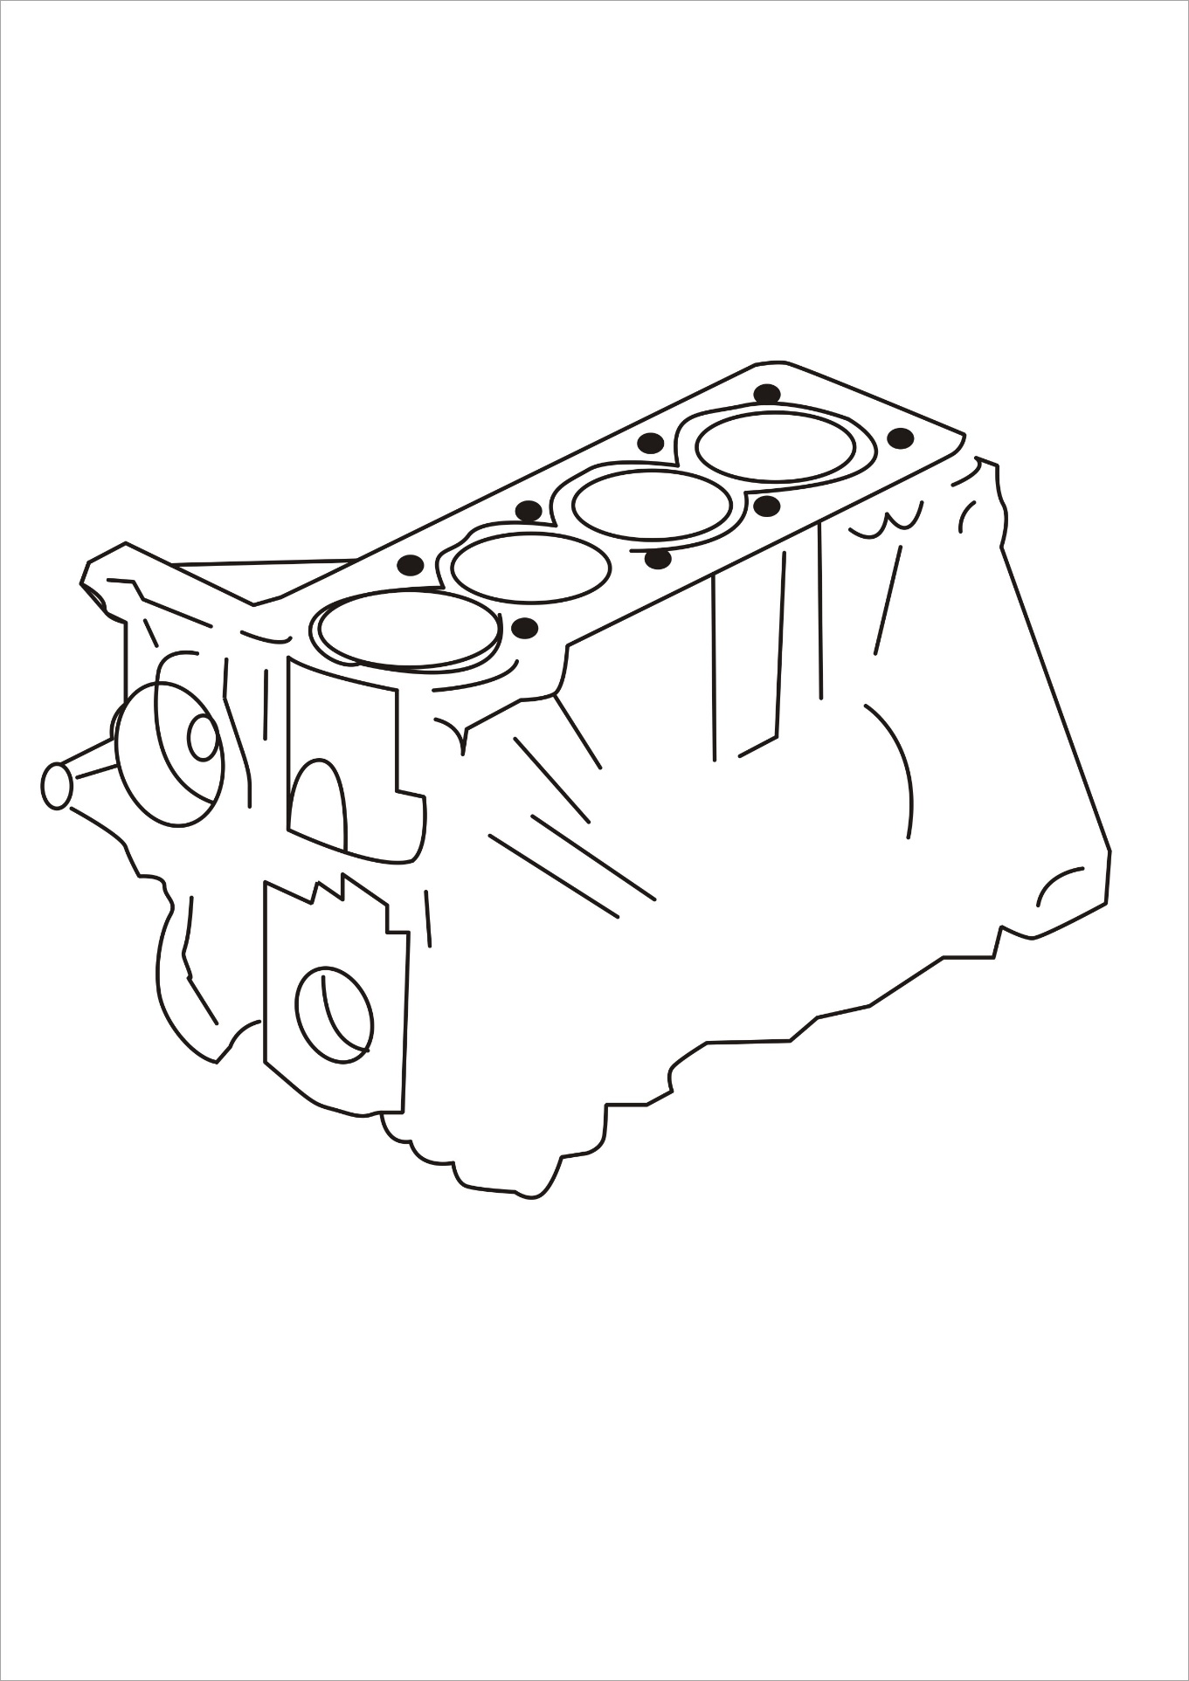
Figure 3.2: Engine Block

CHAPTER FOUR

CONCLUSION AND RECOMMENDATIONS

4.1 Conclusion
In conclusion, the work experience encompassed three essential engine repair tasks: changing piston rings, removing the top cylinder, and changing bearings. Each task was undertaken to address specific complaints—overheating and stalling, loss of compression and abnormal noise, and knocking noise with reduced performance, respectively. The procedures involved meticulous disassembly and reassembly, careful inspection of parts, and adherence to torque specifications to ensure effective and safe repairs.
Throughout these tasks, maintaining a clean work environment, following manufacturer guidelines, and inspecting all components for wear or damage were critical precautions. These measures were crucial in preventing contamination, ensuring proper assembly, and promoting the engine's longevity and performance. This experience underscores the importance of methodical procedures and best practices in engine maintenance and repair, contributing to the vehicle's reliability and optimal functionality.

4.2 Recommendation
- Students often face challenges during their SIWES (Student Industrial Work Experience Scheme). To address this, it is recommended that the organization where the student undertakes SIWES provides an allowance to support them financially.
- Additionally, the Industrial Training Fund (ITF) should ensure prompt payment of allowances once students complete their industrial training.
- The institution should strive to establish connections with various companies to facilitate the placement of students during their SIWES period. This will help in evenly distributing students across different organizations, enhancing their learning experience.
- Regular check-ins and evaluations should be conducted to ensure that the students are gaining practical and relevant experience.
- Furthermore, the institution itself should provide consistent supervision, offering guidance and support to the students throughout their industrial training. This dual supervision will ensure a comprehensive and beneficial SIWES experience for all students.

REFERENCES
Green, J. N. (1964). Introduction to Technical Drawing: Metal work theory for school certificate and GCE, McGraw Hill, New York.
Chapman, W. (1972). Work shop technology. Published by Hodder Headline Group

